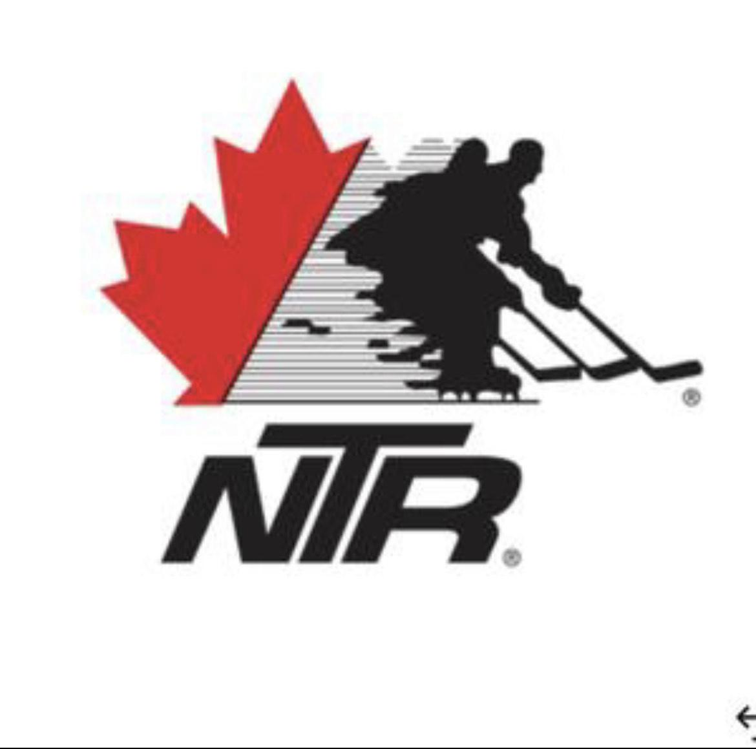

**Waiver of Liability**

**Name of Participant:________________________________________**

**Date of Birth:______________________________________________**

**Name of Parent/Guardian:___________________________________**

**Team Name:______________________________________________**

**Emergency Contact Information**

**Phone Number:____________________________________________**

**Email:___________________________________________________**

**Waiver of Liability:**The student applicant on the application and their parents/guardians agree that the National Training Rinks (N.T.R.), shall not be held responsible for any injury, loss or damage whatsoever occurring to the participant while the participant is in attendance at N.T.R. programs or including while the participant is within the premises occupied by N.T.R.

I/We acknowledge and agree that N.T.R. reserves the sole and exclusive right to use any photographs or videos taken during the program for advertising and/or instructional purposes, without cost or charge to N.T.R. and the I/We consent to photographs or videos being taken for the purposes contained herein.

I/We consent to the participants or my attendance on the terms of this waiver of liability or in the case of a guardian of a person under 19 years of age grant our consent to the terms of this waiver.

I/We acknowledge reading this Application and Declaration and understand the conditions contained herein and agree to abide by all terms.

**Print Name:_____________________**

**Signature:_______________________Date:______________________________**